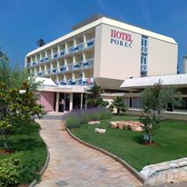
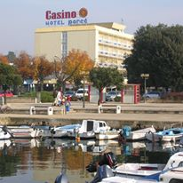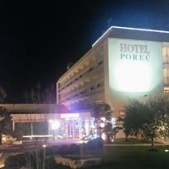
Offer for accommodation in hotel Poreč
POREČ FEST for violinist (12.04.-16.04.2018.)
Dear guests.
We are glad to offer you accommodation B&B in our hotel per person a day for the next price:
- Standard double room
298 kn (cca 40€)
- Superior Double room
335 kn (cca 45€)
- Standard Single room
417 kn (cca 56€)
- Superior Single room
454 kn (cca 61€)
- Stadndard triple room
298 kn (cca 40€)

Supplement for: - half board (HB) 90,00 kn (cca 12€) per person a day
- full board (FB164,00 kn (cca 22€) per person a day
Residence tax 6,00 kn cca 0,83€ per person a day
Discount for the children: - 0 – 3 years gratis
- 3 - 7 -50%
- 7 - 13 -20%
Reservation send to e-mail address info@hotelporec.com or telefon nr.00385 52 451 811.
Payment: - directly on reception of hotel Poreč (cash ili creditcard)
- Proforma invoice on hotels IBAN
Poreč, 05.11.2017. Hotel Poreč

